**ECE375 Final Project**

**Introduction:**

In this project we have to calculate the satellite velocity and period of revolution of a satellite for different palents like earth ,mars jupiter etc.

As we know that

The satellite velocity formula is

V $=\sqrt{GM/R^{ }}$

Here M is the mass of planet and G is gravitaional constant.And R is the Orbital radius of the planet.As the mass and radius of each planet are different from each other so the velocity of satellite around each planet will be different.

Similarly the period of revolution is

$T=\sqrt{4π^{2}R^{3}/GM}$

The period of revolution depends on the radius of planet and mass of planet as well as on some constants.Here T denotes the period of revolution.

These two parameters changes from planet to planet.

**Part of Code implementaion :**

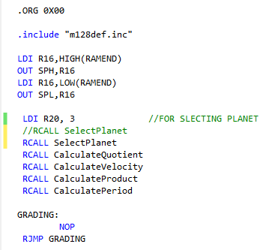

**Code explanation:**

In above code first of all we have included header file as we are using atmega128 so to show registers settings and other compulsory things it was necessary.After that the stack is initialized because as we call any function in our code first its return adddress is saved in stack then the function is called.In the next step,we select the palnet number for which we want to calculate the velocity and period of revolution.Furthermore,we call the function named as quotient.This function calculates the quotient(GM/R) and then the velocity is calculated by taking square root of this quotient.

For calculating period of revolution first we calculate the product which is the multiplication of constants which are as ($4π^{2}R^{3}$) after that thevalue of the period is calculated by dividing the product by GM value and after that we take sqaure root.CalculateProduct and CalculatePeriod are performing these functions and in the last our programe jumps to the grading point and remains there infinitely.

**Output:**

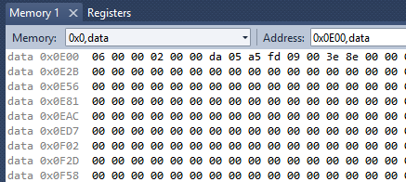

In the above snippet the output is shown.The first three bytes define the quotient in the bigendian notation and after that the velocity is shown in 2 bytes and next 7 bytes define the product and in the last 3 bytes the period of the revoltion result is present.This result is 15 bytes and it is distribution of different parts.The location of this result is in data memory and the location of the memory is 0x0E00. All the values are present in the big endian notation and the format of the values is hexadecimal. We can also observe the status of all the regsisters in during the debugging of programe as well as after the execution of the programe in the register window.The output window offer data memeory view as well as programe memeory view and register status window.

**Block Diagram:**

Select Planet

Main

Calculate

Quotient

Initialize

Stack

Calculate Velocity

Grading

Calculate Period

Calculate Product

The main working of the project is explained in the above block diagram.The maximum number of bits that an individulal variable can store is 32bit. easily.The maximum value can be stored in individual is 4 bytes so the value whose square root can be determined by our programme is 4 bytes.And in decimal it is 4,294,967,265.for calculating division we have used the subtraction method in which we have subtracted the number so many times as to it remained negative.This technique describes both the quotient and remainder.Similarly for squareroot we have stated from 0 and moved to the number closer to original by taking perfect square.The most difficult part of the programme was to calculate the squareroot and division of the numbers.

**Primary challenges to Implement the project:**

The main problem in this project was the designing of this project and the second problem was the variables handling.Because these equations contains the large numbers as a result of mulltiplication,square roots and cube roots. So for this reason the exact and effeicent selection of variable was required because if selacted variable is short then it will overflow and will cause the errroneous result.The second problem was the design phase of the project as to create functions and calling them orderly in the main function was very essential.Last but not division in avr is very complicated as it has no command for division of two numbers except by adopting other method.

**Pie chart to explain time consumption:**

The most time is spent on the debugging and error solving of the code.Second thing on which our time is spent is programming and last but not least thing is the design and reserch section on which our time is spent.In these three parts the first section was design and reserch phase after that the programing has done and the errors and bugs are solved and final resul is represented.

**Conclusion:**

So it has been concluded in this project that the equations can be easily solved by this avr controller and these equations are very important and very useful for satellite systems.These basic equations are very popular and useful in physics and satellite’s world.Overall, this project demostratesus the method of world with higher number of bits rather than 8 bit.